11. Design and implement the 4:1 MUX using gates /ICs.

AIM: To design and implement the 4:1 MUX using gates /ICs.

Theory:

Multiplexers are very useful components in digital systems. They transfer a large number of information units over a smaller number of channels, (usually one channel) under the control of selection signals. Multiplexer means many to one. A multiplexer is a circuit with many inputs but only one output. By using control signals (select lines) we can select any input to the output. Multiplexer is also called as data selector because the output bit depends on the input data bit that is selected. The general multiplexer circuit has 2n input signals, n control/select signals and 1 output signal.

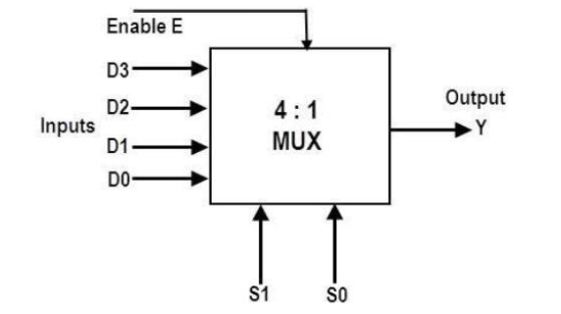

4:1 MULTIPLEXER

To get the total data output from the multiplexer, all these product terms are to be summed and then the final Boolean expression of this multiplexer is given as

Logic Gate:
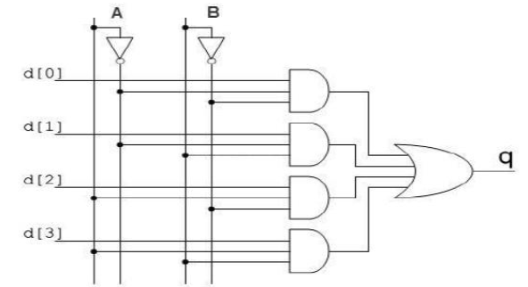

Pin Diagram:
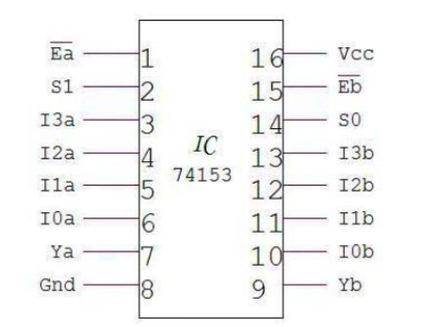

Truth Table:
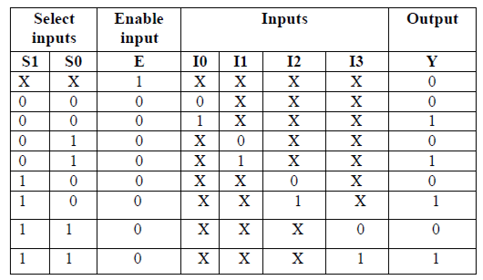

PROCEDURE:
1) Connect the circuit as shown in figure.
2) Apply Vcc & ground signal to every IC.
3) Observe the input & output according to the truth table.

